Discovery Approach for Tfs

**Scope**

The objective of this document is to find out all the workitems on the Tfs side from project perspective.

**Pre-requisites**

* Python installed on your system with a version of 3.9 or higher.
* The required Python packages should be installed, including os, time, dateutil, pandas, get_list_of_branch, tfs, requests_ntlm.
* Access to a TFS server with a username and password.
* The path to the source directory where the Git repository is cloned.
* The name of the project and the URL of the TFS server.

**Execution Steps**

* Imports necessary packages, credentials, and functions.
* Defines global variables for the TFS URL, username, password.
* Execute the python code to fetch the total count of work items in TFS
  + Python discovery-work-item.py
  + 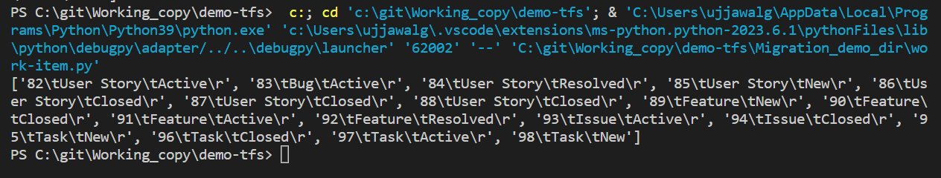
* Check for the discovery report Discovery Report – WorkItems.xlsx
  + 